COMP4500 – Assignment 1

Robert Cochran 43135132

**Q1. A) 984313513252**

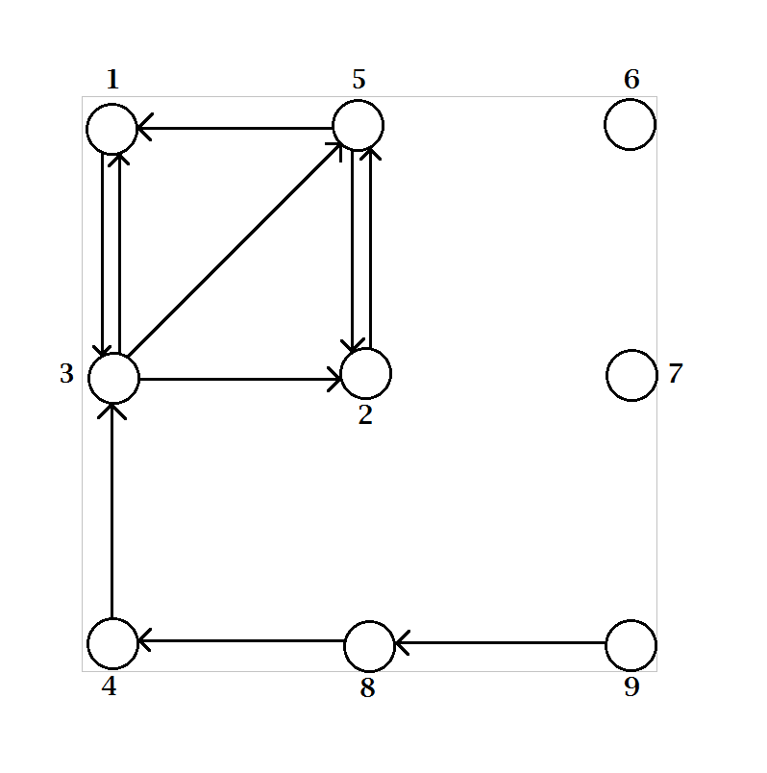

**Q1. B) Graph S**

**Q2.A) Step 1 of SCC(***S***)**

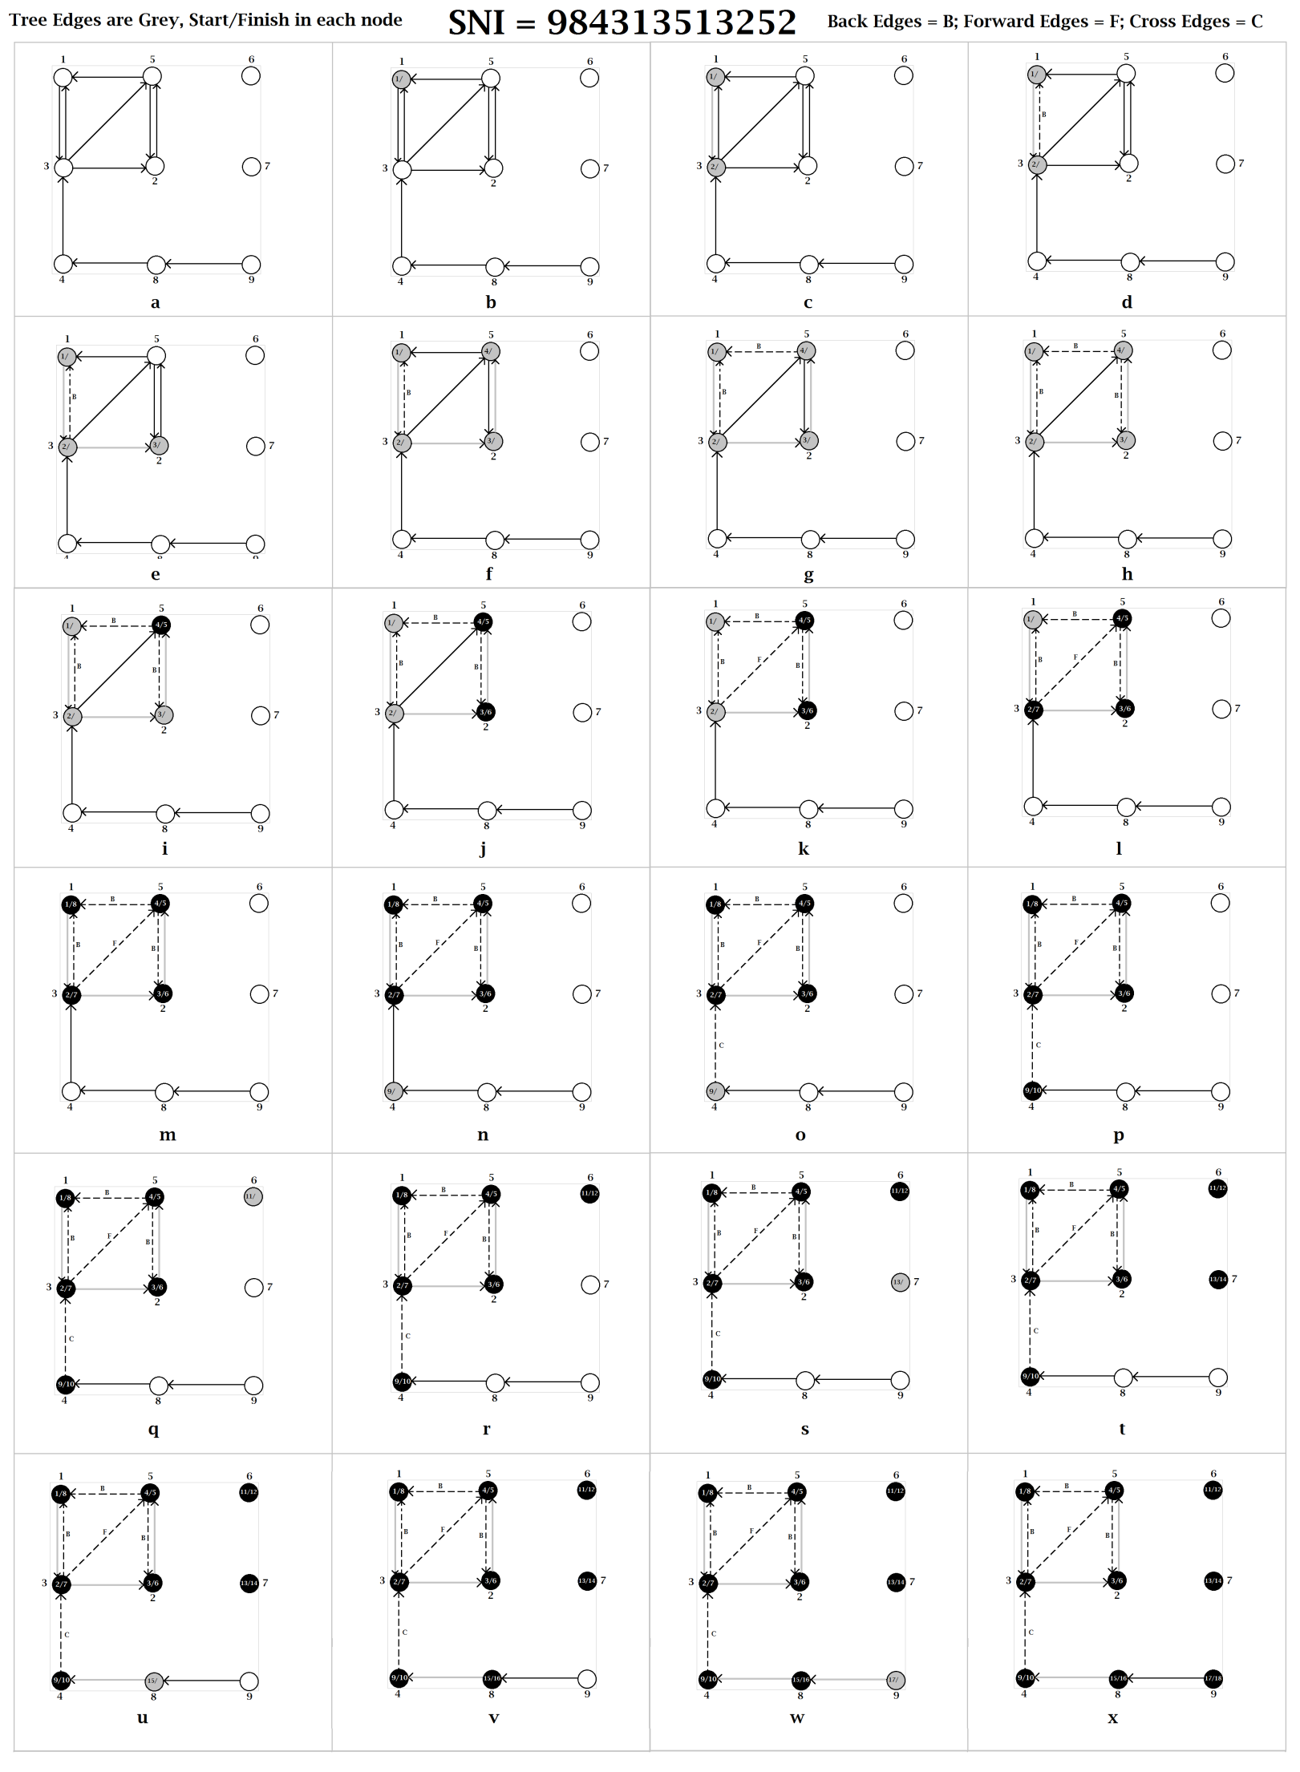

**Q2. B)**

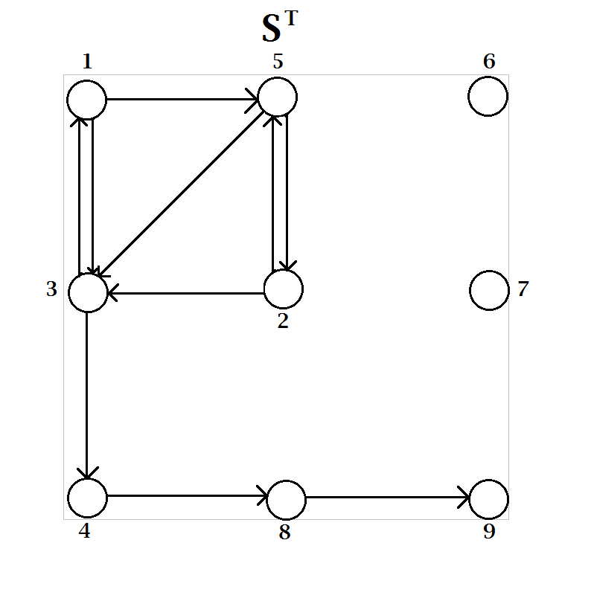

**Q2. C) (9) (8) (7) (6) (4) (1,3,5,2)**